**Application Server Installation Guide:**

**The Bookshare**

This document has been designed to guide you through the server installation of the bookshare software.

*Step I: Setup mySql workbench*

MySQL Workbench is a unified visual tool for database architects which will help us to work with SQL. MySQL Workbench provides DBAs and developers an integrated tools environment for SQL Development.

*Step II: Setup the database Server*

Download the Database Web Server Software Installation Guide from google and follow its instructions carefully to setup the My SQL Server.

*Step III: Setup the Web Server*

Download Xampp

XAMPP is an easy to install Apache distribution containing MariaDB, PHP, and Perl. . Just download and start the installer. It's that easy.

*Step IV: Create the Database*

After completely downloaded MySQL, run the BookShare_setup.sql file to create database tables.

*Step V: Add Data to the Database*

While running the database on MySQL, insert the data into ‘users’ table by using the following command if the data is saved as a text document in your downloads folder:

**insert the data into ‘users’ table by using the following command:**

load data local infile'~/Downloads/data/user.txt' INTO table users;

**insert the data into ‘books’ table by using the following command:**

load data local infile '~/Downloads/data/book.txt' INTO table books;

**insert the data into ‘items’ table by using the following command:**

load data local infile '~/Downloads/data/item.txt' INTO table item;

*Step VI: running the application*

Place your application inside htdocs file (which is located in xampp), go into the config file and set the database username and password. Once your server is started, enter localhost/BookShare/public from your browser.

The homepage of the BookShare web application will be:

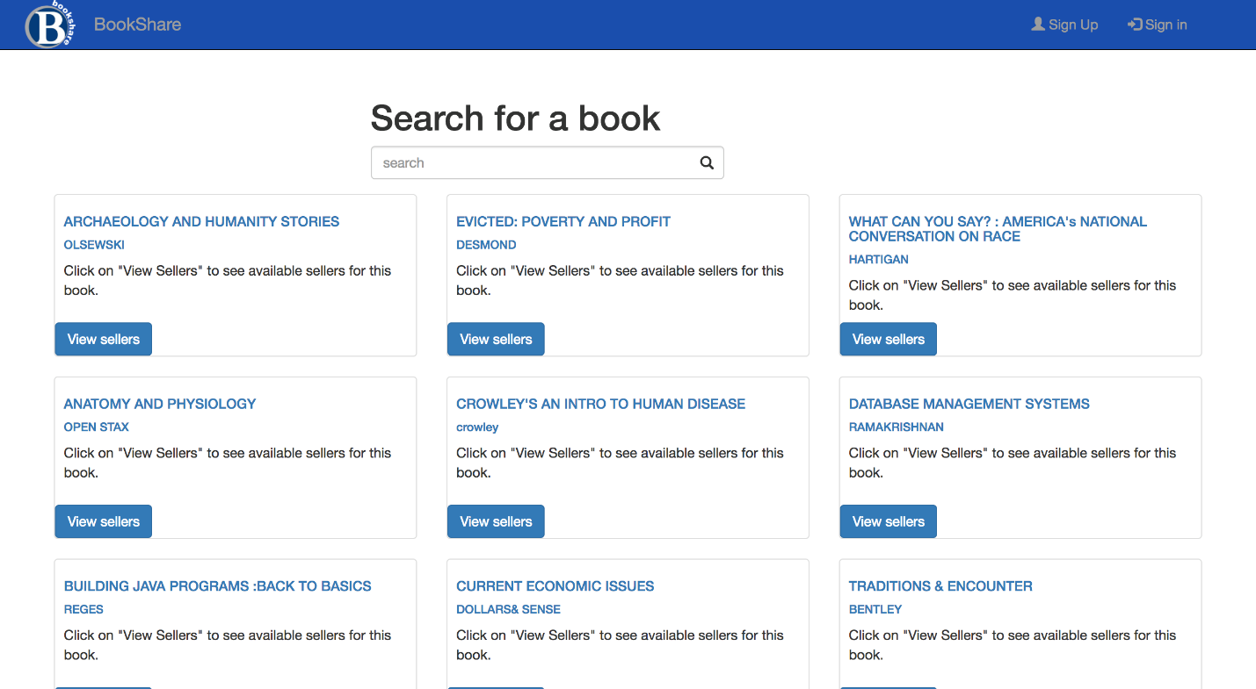

Once you are able to access the homepage, you are able to browse and see which books are available without a BookShare account. To access further functionalities, you will have to create a BookShare account by clicking the “Sign Up” Button.